**1** The diagram shows the process of fertilisation.

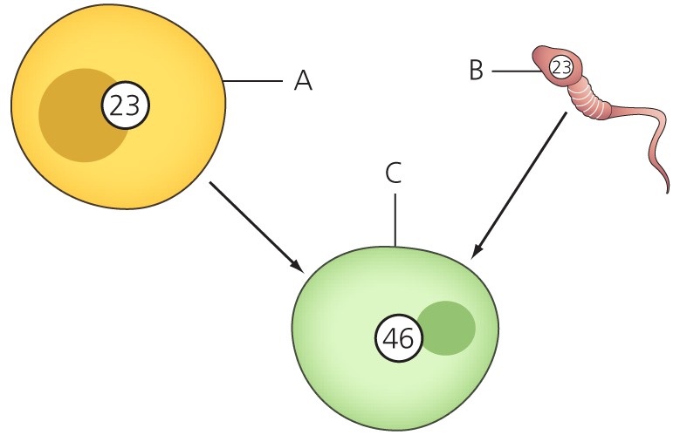

**a)** Label A, B and C on the diagram. (3)

**b)** What are the numbers inside A, B and C representing? (1)

**c)** Explain how cells A and B determine the sex of C. (2)

**2** Mitosis and meiosis are two different forms of cell division. Decide whether each statement below refers to mitosis or meiosis.

**a)** Creates four genetically different cells.

**b)** Bacteria reproduce by binary fission.

**c)** Creation of gametes in a human.

**d)** One haploid cell divides to form more haploid cells.

**e)** Used for growth and repair. (5)

**3** The diagram shows the relationship between a chromosome and DNA.

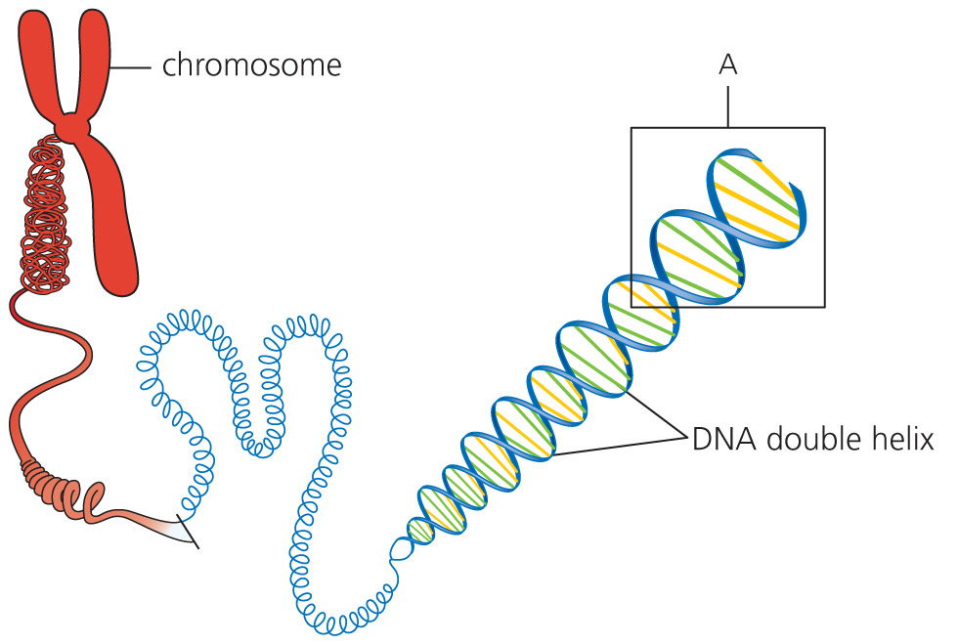

**a)** Where in a cell are the chromosomes located? (1)

**b)** What term can be used to describe one complete copy of all the DNA in a  
diploid body cell? (1)

**c)** DNA is made up of units called nucleotides. A nucleotide consists of a DNA base  
and two other molecules. What are these other molecules? (2)

**d)** There are four DNA bases. One of them is adenine (A). Name the other three. (3)

**e)** The section labelled A has been enlarged in the diagram below. This shows how DNA nucleotides are bonded together. The DNA base adenine has been labelled. Complete the diagram to where all the other bases fit.

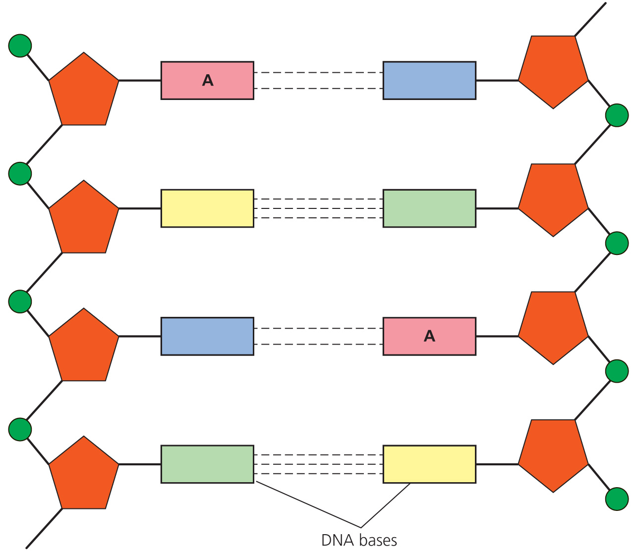 (3)

**f)** DNA bases fit together in a very precise way. What term describes the way they match? (1)

**4** Fill in the gaps in the paragraph on protein synthesis with the most appropriate word or words.

A strand of DNA called a ……… carries the instructions for making one protein. Proteins are made of chains of amino acids. The order of the amino acids is determined by the order of the DNA ……… . The first stage of protein synthesis is called ………. . Here a copy of the DNA code is made into a strand of ……… RNA. mRNA moves out of the ……… to the cytoplasm. mRNA attaches to a ………. . The second stage of protein synthesis is called ……… . Three bases on the mRNA correspond to ……… amino acid. Amino acids are brought to the mRNA by ……… . The amino acids line up and are bonded together to form a polypeptide. The polypeptide folds into the correct shape. Enzymes and ……… are proteins.

**ribosome   translation   hormones   gene   transcription   nucleus**

**one   tRNA   bases   messenger** (10)

**5 a)** Match the genetic term with its correct description.

|  |  |
| --- | --- |
| Term | Description |
| Dominant | An alternative version of a gene. Inherited from one parent |
| Phenotype | Having two identical alleles for a characteristic |
| Homozygous | The alleles that make up the visible characteristics of an organism |
| Allele | An allele that will have its effect if inherited from only one parent |
| Genotype | The visible or physical characteristics of an organism |

(5)

**6** Cystic fibrosis is a genetic disease. Patients with the disease produce thick, sticky mucus in their lungs and gut. The mucus makes it more difficult to breathe and digest food. Patients often have bacterial infections.

**a)** Why do cystic fibrosis sufferers contract bacterial infections? (1)

**b)** What treatment do you think they are given to help relieve any symptoms of the disease? (2)

**c)** The family tree shows the inheritance of the cystic fibrosis allele. The normal allele is represented by C. The cystic fibrosis allele is represented by c. Which allele is dominant? (1)

**d)** Answer the questions using the information in the family tree.

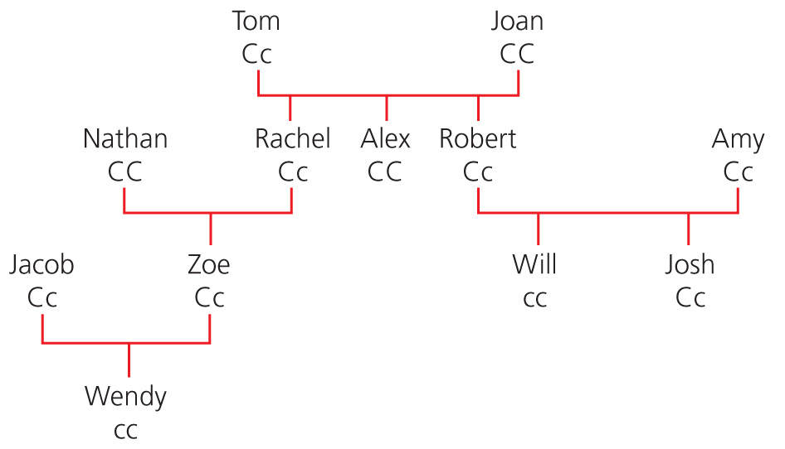

**i)** How many generations are shown by the family tree? (1)

**ii)** What relation is Wendy to Tom and Joan? (1)

**iii)** Describe the genotype and the phenotype of Jacob and Zoe. (2)

**iv)** Amy and Robert are described as symptomless carriers. Explain what this means. (2)

**v)** Robert and Amy are expecting another child. Complete the punnet square to show the possible genotypes of the new baby.

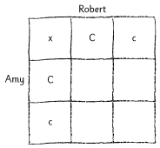 (2)

**vi)** What is probability that the baby will have cystic fibrosis? (1)

TOTAL = 50

**1 a)** A = egg; B = sperm; C = zygote (3)

**b)** The number of chromosomes. (1)

**c)** Sperm carries either an X or Y chromosome; egg carries only an X chromosome.

If the egg is fertilized with an X sperm, the baby will be XX (girl).

If the egg is fertilized with a Y sperm, the baby will be XY (boy). (2)

**2** **a)** meiosis

**b)** mitosis

**c)** meiosis

**d)** mitosis

**e)** mitosis (5)

**3 a)** nucleus (1)

**b)** genome (1)

**c)** sugar and phosphate (2)

**d)** cytosine (C); thymine (T); guanine (G) (3)

**e)**

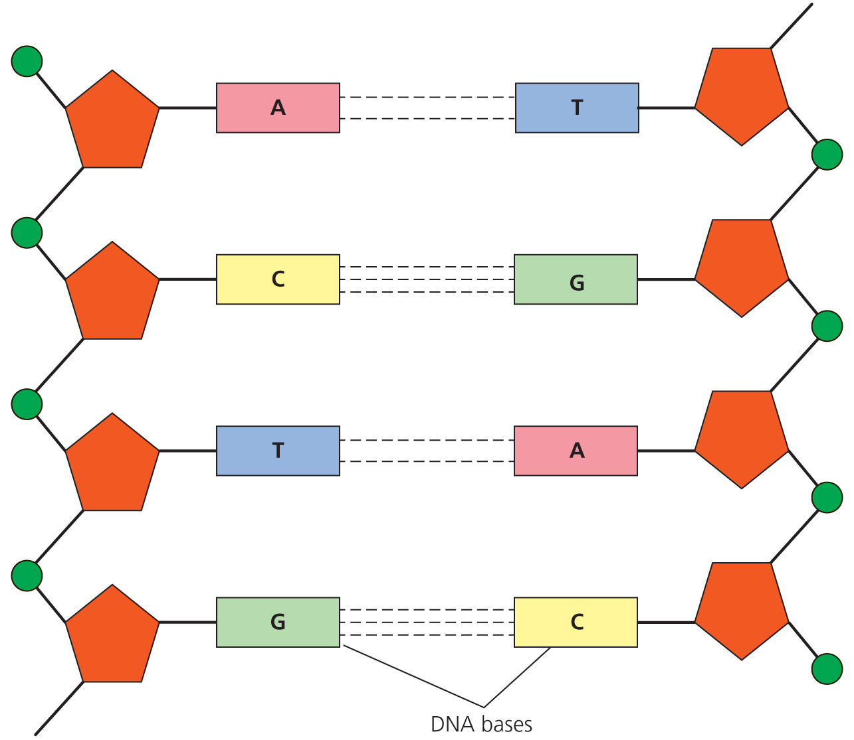

(1 mark for all T, 1 for all G, 1 for all C. C and G either order = 3)

**f)** complementary (1)

**4** A strand of DNA called a **gene** carries the instructions for making one protein. Proteins are made of chains of amino acids. The order of the amino acids is determined by the order of DNA **bases.** The first stage of protein synthesis is called **transcription.** A copy of the DNA code is made into a strand of **messenger** RNA. mRNA moves out of the **nucleus** to the cytoplasm. mRNA attaches to a **ribosome**. The second stage of protein synthesis is called **translation**. Three bases on the mRNA correspond to **one** amino acid. Amino acids are brought to the mRNA by **tRNA**. The amino acids line up and are bonded together to form a polypeptide. The polypeptide folds into the correct shape. Enzymes and **hormones** are proteins. (10)

**5**

|  |  |
| --- | --- |
| Term | Description |
| Dominant | An allele that will have its effect if inherited from only one parent |
| Phenotype | The visible or physical characteristics of an organism |
| Homozygous | Having two identical alleles for a characteristic |
| Allele | An alternative version of a gene. Inherited from one parent |
| Genotype | The alleles that make up the visible characteristics of an organism |

(5)

**6** **a)** Bacteria stick to the mucus; the mucus is not moved around the body easily (1)

**b)** antibiotics; physiotherapy; capsules of enzymes (2)

**c)** normal (1)

**d)** **i)** 4 (1)

**ii)** great granddaughter (1)

**iii)** Genotype is heterozygous Cc; phenotype is normal; Jacob phenotype male; Zoe phenotype female. (2)

**iv)** They both carry the allele for cystic fibrosis; but because it is recessive, they do not suffer from the disease and show no signs (symptoms) of the disease. (2)

**v)**

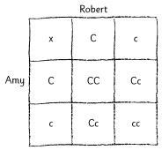

(1 mark per correct line = 2)

**vi)** ¼ or 25% or 1 in 4 (1)

TOTAL = 50